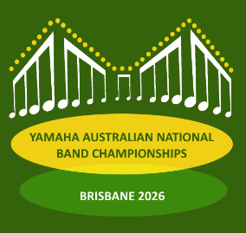
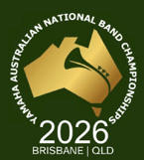

2026 YAMAHA AUSTRALIAN NATIONAL BAND CHAMPIONSHIPS BRISBANE, QLD
Registration & Grading Declaration Form

This form must be completed by the Competing Band and forwarded to the State Governing Body with which you are registered no later than 6th March 2026. Should any portion of this Declaration be found to be untrue, the Championships Committee may withhold any prize / prizes won by the declaring Band or a member thereof pending any action by the National Band Council of Australia Inc.

Declaration
On behalf of the Band, which is entered in the Grade, I declare that this form has been completed in compliance with the requirements of the NBCA Contest Regulations as contained in the 2026 NBCA Contest Yearbook.

Signature: | Name: | Position: | Date:

Instructions to Assist with Completion of this Form
Only players registered 42 days prior to the Championships (20th February 2026) may compete at the Yamaha Australian National Band Championships. NOTE: Conductors must also be listed on this form
It is suggested that bands consider having all registered players listed this declaration. Any player who is listed and then does not compete can simply be deleted. Any player who has not been listed on this declaration and has not been verified by their State Governing Body cannot be added at the time of the competition.

NO SIGNATURES REQUIRED – PLEASE LIST NAMES ONLY
Permit players must be arranged and approved as per the Contest Regulations and, if approved at the time of completion of this form, their names should be listed in the appropriate section below.

Please return these forms to Your State Governing Body no later than 6th March 2026

Declaration by State Governing Body Secretary
As the Secretary / Registrar of (State Governing Body), I
declare that I have verified that all names on the following list are registered with my State Governing Body and are eligible to play with the band named above.
Further, I declare that this band is eligible to compete in the listed grade and satisfies all eligibility requirements in accordance with the Contest Regulations contained in the 2026 NBCA Contest Yearbook and is endorsed for competition at the 2026 Yamaha Australian National Band Championships.

Signature: | Name: | Date:

Once verified, State Governing bodies please forward these forms to the Contest Administrator no later than 13th March 2026

Band Name: Page No:…… of (total pages)

Instrumental Players
Print this page more than once if there is insufficient space for your band. Please put band name & number each page.

OFFICIAL USE ONLY |  | NAME |  | DOB | REGISTERED BAND
Day 1 | Day 2 | Surname | Given Name | (Juniors only) | Registered band if player from another grade

Print this page more than once if insufficient space for your band. Please put band name & number each page.

Conductor

OFFICIAL USE ONLY |  | NAME
Day 1 | Day 2 | Surname | Given Name
Percussion Players Only
Bands are entitled to use as many Registered Percussion Players as the score requires.

OFFICIAL USE ONLY |  | NAME |  | DOB  Juniors
Day 1 | Day 2 | Surname | Given Name

Instrumental Permit Players Only
Brass Bands are entitled to Four (4) Instrumental Permit Players Concert Bands are entitled to Six (6) Instrumental Permit Players
OFFICIAL USE ONLY |  | NAME |  | DOB  Juniors
Day 1 | Day 2 | Surname | Given Name

Percussion Permit Players Only
Bands are entitled to use as many Percussion Permit Players as the score requires.

OFFICIAL USE ONLY |  | NAME |  | DOB  Juniors
Day 1 | Day 2 | Surname | Given Name

